Currency Counters/Discriminators - Bank & Casino Models
- 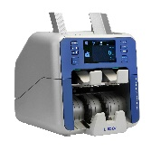ML-1 VS Dual Pocket Value Count High Speed Discriminator

- ML-2 FS Dual Pocket Fitness Sort – Value and Bill Fitness Sorting
Discriminator (ATM Bill Fitness Sorting)

- 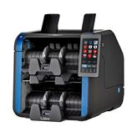ML-250 3 Pocket Value Count High Speed Discriminator

- 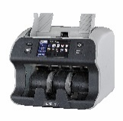CL-2 Single Pocket Currency Discriminator

- 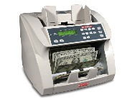Seamacon

- 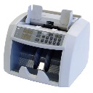 Focus Banker

- 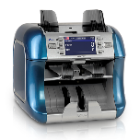 Newton A 2 Pocket Value Count Currency Discriminator

- 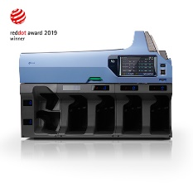K-6 Multi Modular Currency Discriminator/Sorter
(add additional modules)

Check Scanners/Imaging
- 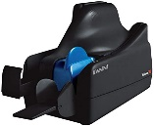Panini VX -50, 75, 100

- 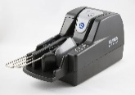Burroughs Smart Source

- 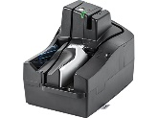Digital Check TS-500

- 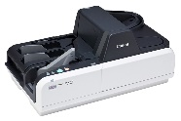Canon CR-190ii

- 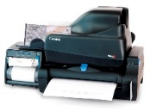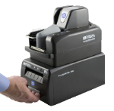Check Scanner/Printer Combo (all models)
Contact for details and pricing

Check Scanner/Printer Combo
- 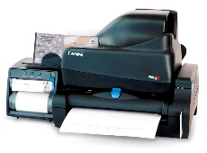Panini VX Series

- 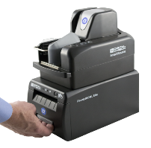Burroughs Smart Source

- Digital Check TS-500

Teller Printers/Validation Printers
- Epson

- 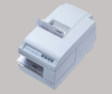TPG

Check Encoders
- 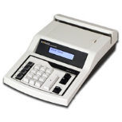Maverick MICR M-360/MX3

- 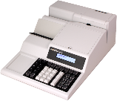Maverick MICR M570

Coin Sorters & Packagers
- 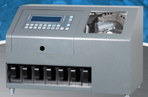High Speed Coin Sorter

- 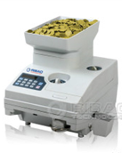Desk Top Coin Packager

- 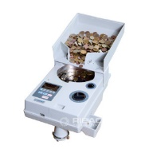Portable Coin Packager

Coin Wrappers
- Laurel High Speed Heavy Duty Coin Wrappers

Shredders
- 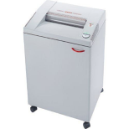Medium / Heavy Duty – Shred and Cross Cut

- 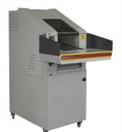Large Volume Bulk Shredders – Shred and Cross Cut

Service and Repair (On Site and Depo)
- Currency Counters
- Check Scanners
- Teller/Validation Printers
- Check Encoders
- Coin Equipment
- Shredders

Cleaning & Maintenance Supplies
- 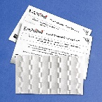Scanner Waffle Cleaning Cards w/Wonder Solvent

- 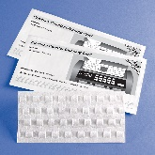Currency Counter Waffle Cleaning Cards w/Wonder Solvent

- 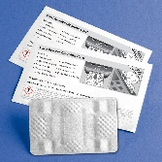ATM Card Reader Waffle Cleaning Cards w/Wonder Solvent

- Casino Card Reader Waffle Cleaning Cards w/Wonder Solvent

- Cleaning Swabs w/Wonder Solvent

- Validation/Teller Printer Paper Rolls

- Validation/Printer Ribbons

- Check Scanner Ink Cartridges

Automated Check & Payment Processing Software (Business, Bank, Financial)
- Automated Lockbox Processing, Automated Payment Processing, Branch Capture, Remote Deposit, Web Hosted Remote Deposits.

“If you handle checks or payments we have software to automate the processing”

The MirrorImage system can be configured to handle several different item processing
environments including (but not limited to):
*Remote Deposit System
*Proof of Deposit System
*Branch Capture System
*Payment Processing System
*Backend Check Imaging System
*ATM Deposit System

